Student Name: Lau Ling Wang, Cheung Ho Chun
Student ID: 250230786, 250036418
Course: ITE3006: IT Essentials - Web
Assignment: EA2 - A Client-side Web Site of Your Own Interest
Topic: Football Club Website

1. Project Overview
This project involves the design and development of a multi-page, client-side website for a football club. The website is built using HTML5, CSS3, and vanilla JavaScript, adhering strictly to the assignment's constraints. The primary goal of the website is to promote the club, provide information to potential members, attract new visitors to join the community, and educate visitors about the history of football.
The website consists of four interconnected pages, creating a coherent user journey from introduction to membership. Additionally, a "History of Football" page provides educational content for enthusiasts.

2. Website Structure and Pages
The website is structured around a central navigation menu, ensuring seamless movement between its four core pages. The file structure is organized by file type for better maintainability.

File Structure:
- index.html - The homepage (Start page)
- AboutUs.html - Information about the club
- JoinUs.html - A form for potential members to sign up
- HistoryOfFootball.html - Educational page about football history
- css/style.css - All global and page-specific styles
- js/script.js - All client-side JavaScript logic
- img/ - Folder for images (including GIFs and local images)

Page Details:

1. index.html (Homepage)
Purpose: To serve as the main landing page, providing a quick overview of the club and its core activities. It aims to create an immediate, positive impression and encourage further exploration.
Features:
- Navigation Menu: A clear navigation bar with links to all pages and external football club websites (Real Madrid and Manchester United).
- Welcome Section: A prominent welcome message with the club name and a decorative football GIF to create visual appeal.
- Club Image: A club-related image to enhance visual engagement.
- External Links: Direct links to Real Madrid C.F. and Manchester United official websites for visitors interested in other clubs.
- Navigation Links: Clear links to "About Us," "Join Us," and "History of Football" pages.
Code Location: index.html
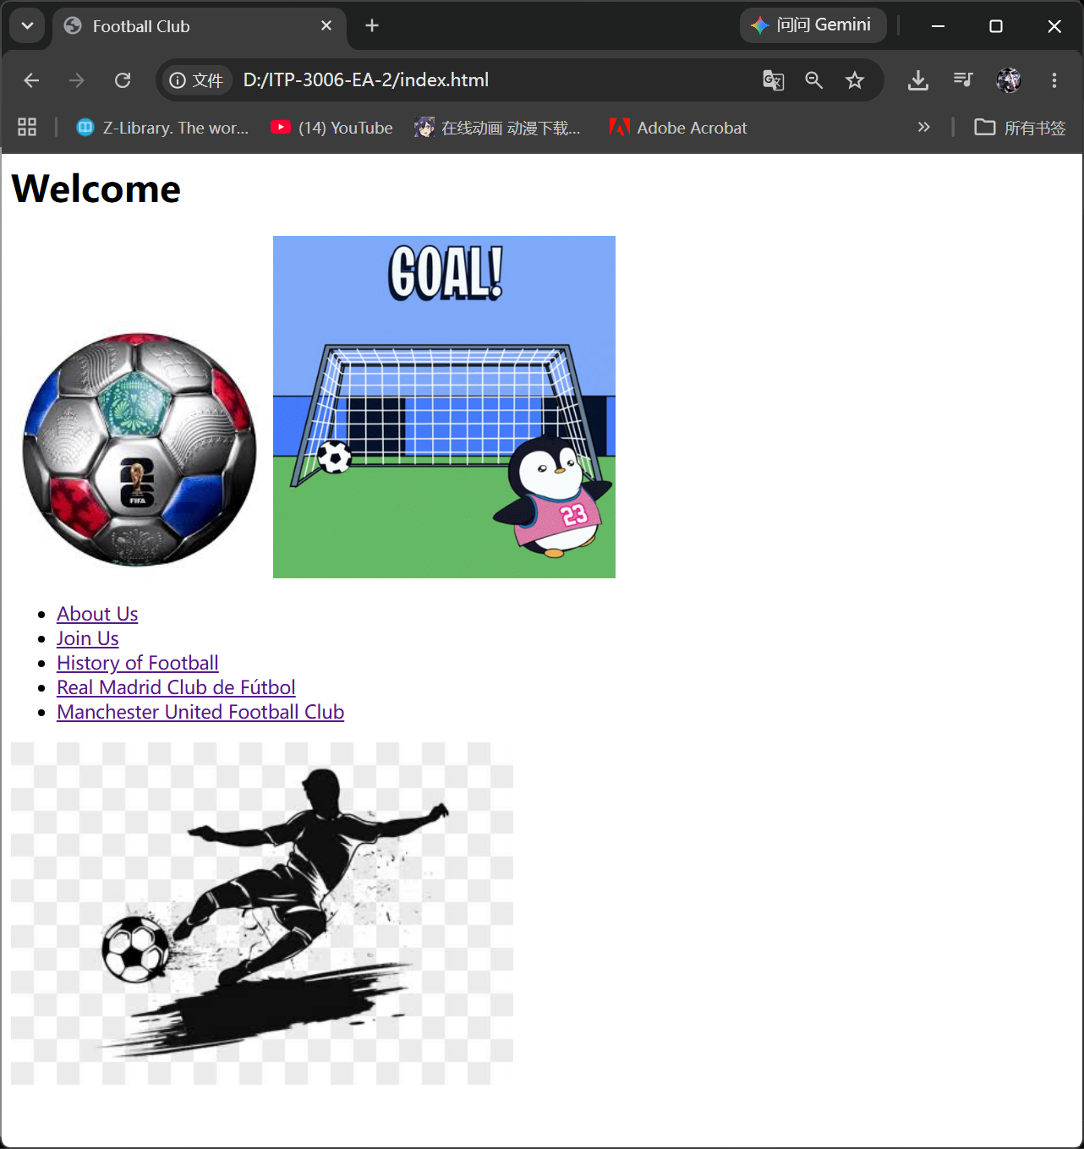

2. AboutUs.html (About Us)
Purpose: To provide in-depth information about the club's identity, values, and community. This page builds trust and connection with the visitor.
Features:
- Welcome Header: A clear "About Us – Welcome to Football Club" heading.
- Animated Element: A soccer GIF positioned at the top-right corner using CSS absolute positioning, adding dynamic visual interest.
- Who We Are Section: Introduction to the club, founded in 2015, with information about the community and mission.
- What We Do Section: Description of activities including training sessions, friendly matches, tournaments, social gatherings, and community outreach.
- Our Values Section: A bullet-point list of core values:
  - Inclusivity – Football is for everyone
  - Excellence – Push each other to improve
  - Community – More than a club; a family
- Why Join Us Section: Benefits of membership including exclusive training, expert coaching, and a supportive community.
- Join the Journey Section: Call to action encouraging visitors to check events, contact the club, and follow on social media.
- Back Link: Navigation link to return to the homepage.
CSS Features:
- .wrapper - Relative positioning container (though not fully utilized)
- .gif - Absolute positioning to place the GIF in the top-right corner with 90px width
Code Location: AboutUs.html, inline CSS
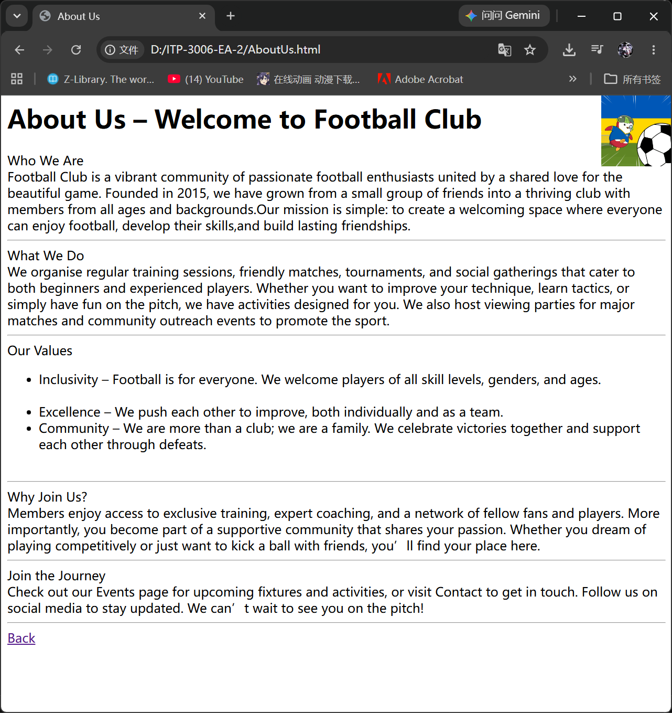

3. JoinUs.html (Join Us - Registration Form)
Purpose: To capture visitor information and convert them into club members. This page features the key interactive form with comprehensive validation.
Features:
- HTML Form: A well-structured form collecting essential member data.
- Input Elements:
  - Name (text input) - Required
  - Gender (radio buttons: M/F) - Required
  - Birthday (date picker) - Auto-set to today's date on page load
  - Email (email input with format validation) - Required
  - Password (password input, minimum 8 characters) - Required
  - Password Confirmation (must match password) - Required
  - Phone (text input, minimum 8 digits) - Required
  - Football Position (dropdown select with all positions: GK, CB, LB/RB, DM/DMF, CM, AM/AMF, LW/RW, ST/FW)
  - Terms Agreement (checkbox with modal popup) - Required
- Submit & Clear Buttons: Form submission and reset functionality.
- Exit Link: Navigation back to homepage.
JavaScript Validation (validateForm() function):
The following sequential validations are performed:
- Name Validation: Checks if name field is empty. If empty, displays alert and focuses on the field.
- Gender Validation: Ensures at least one gender radio button is selected.
- Birthday Validation: Checks if birthday field is empty.
- Email Validation:
  - Checks if email field is empty.
  - Validates email format using regular expression: /^[^\s@]+@[^\s@]+\.[^\s@]+$/
- Password Validation: Checks if password length is at least 8 characters.
- Password Confirmation: Checks if password and confirmation password match.
- Phone Validation: Checks if phone number has at least 8 digits.
- Terms Agreement: Checks if the terms checkbox is checked.
Success Handling: If all validations pass, an alert "Complete registration" is displayed.
Terms & Conditions Modal:
- Trigger: Click the "Membership Service Terms" link
- Content: Complete terms including Preamble, 7 Articles, and Final Clause
- Close Options:
  - Click the × (close) button in the top-right corner
  - Click anywhere outside the modal area
CSS Features:
- #termsModal - Fixed position overlay with semi-transparent background
- .modal-content - Centered white box with padding, border-radius, shadow, and scrollable content
- .close-btn - Styled close button with hover effect
Code Location: JoinUs.html, inline CSS & JavaScript
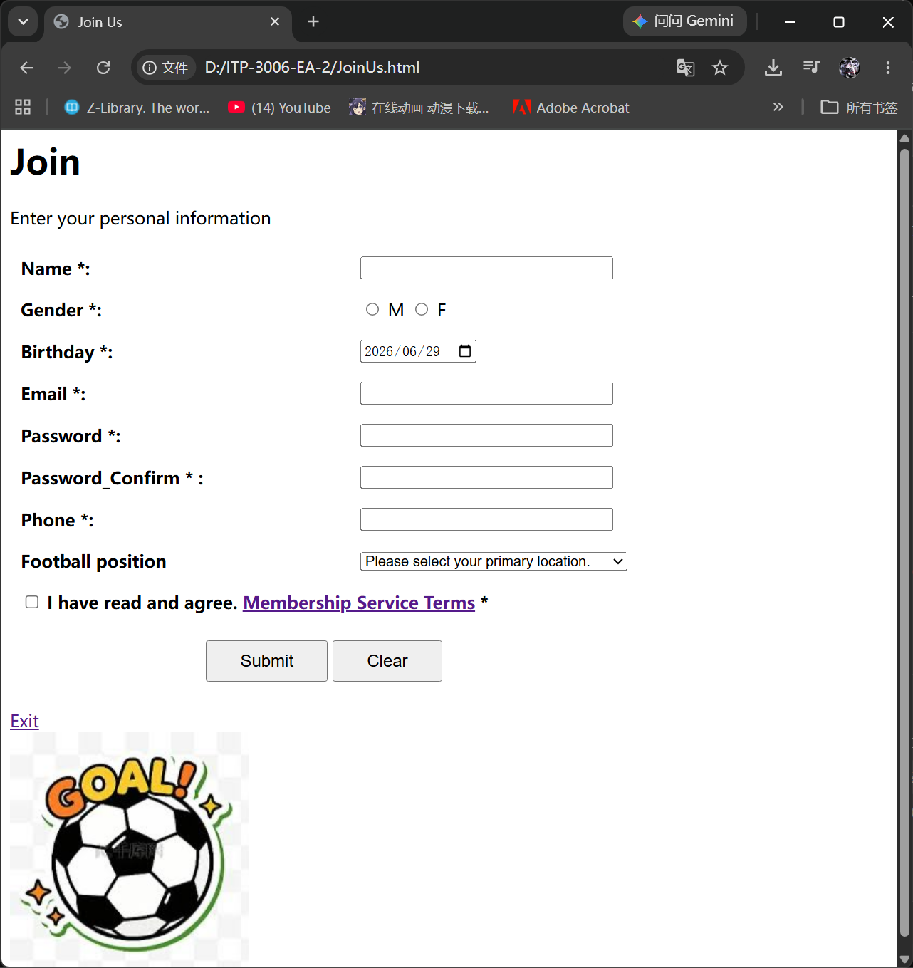

4. HistoryOfFootball.html (History of Football - Educational Page)
Purpose: To provide educational content about the history and evolution of football, from ancient origins to the modern game.
Features:
- Ancient Origins Section:
  - Introduction to Cuju (蹴鞠) - the earliest recorded football game from ancient China (475–221 BC)
  - Information about Han Dynasty military training and Tang/Song dynasty popularity
  - Reference to FIFA president acknowledging football's Chinese origins
  - Mention of Harpastum in ancient Greece and Rome
- The Birth of Modern Football Section:
  - Legend of English soldiers kicking Danish skull
  - Evolution to cow bladder ball
  - 12th century matches in English towns
  - Cambridge Rules (1848) - introduction of 11 players per side
  - Formation of The FA (October 26, 1863) - recognized as the birthday of modern football
- Key Milestones Section:
  - 1871 - FA Cup established
  - 1872 - First official international match (England vs Scotland)
  - 1874 - Offside rule introduced
  - 1885 - Professional football recognized
  - 1888 - English Football League founded
  - 1896 - Football in the Olympic Games
  - 1904 - FIFA founded in Paris
  - 1928 - FIFA World Cup approved
  - 1930 - First FIFA World Cup in Uruguay
- Football Today Section:
  - Global popularity statistics (200+ countries, 211 FIFA member associations)
  - The FIFA World Cup as the most watched sporting event
  - Reflection on football's universal appeal
- Back Link: Navigation to return to the homepage.
- Image: A football-related image to enhance visual appeal.
Code Location: HistoryOfFootball.html
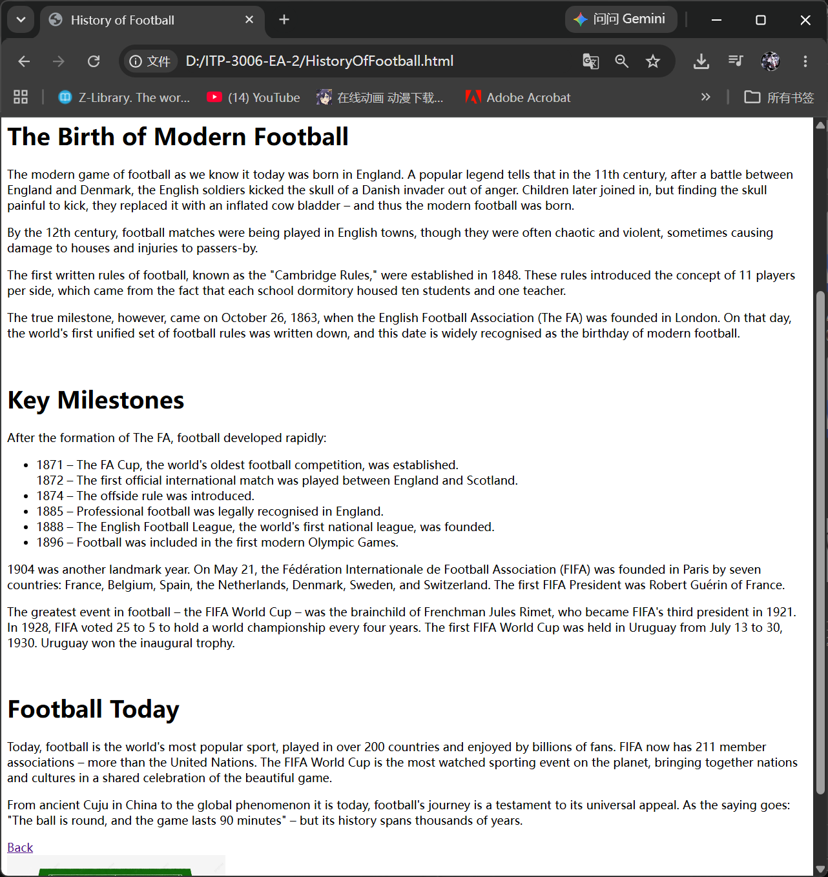

3. Compliance with Assignment Requirements
The submitted website has been developed to fully satisfy all requirements outlined in the assignment brief.
Requirement | Implementation | File/Code Location
Hyperlinks | Navigation menu, back links, external club links (Real Madrid, Man Utd), footer links | index.html, AboutUs.html, JoinUs.html, HistoryOfFootball.html
Text, Pictures, Video | Rich descriptive text content. Images and GIFs used for visual engagement | All pages
Attractive Visual Effects | GIF animations, modal popup, hover effects (close button), responsive styling | AboutUs.html (GIF), JoinUs.html (modal)
CSS-powered Menus | Navigation links styled with CSS (inline styles where applicable) | All pages
CSS-powered Input/Output | Form elements styled with CSS. Output via custom-styled modal and alert messages | JoinUs.html
Responsive Layout | Pages designed to adapt to different screen sizes (with viewport meta tags) | All pages
Validation and Processing | Custom JavaScript validation on the sign-up form with detailed error messages | JoinUs.html

4. User Interaction & Event Handling Design (Important Documentation)
This section explains the key interactive features of the website, detailing how users should interact with the web pages and how the system responds to various events. Special attention has been given to event handling and interactive form processing.

4.1 Navigation & Hyperlinks
User Interaction:
- Users can click navigation links to move between pages:
  - About Us → AboutUs.html
  - Join Us → JoinUs.html
  - History of Football → HistoryOfFootball.html
- Users can click external links to visit real football club websites:
  - Real Madrid Club de Fútbol → https://realmadridhkfc.org/about/realmadrid/
  - Manchester United Football Club → https://www.manutd.com/zh/news
- Users can click "Back" or "Exit" links to return to the homepage.
Event Handling:
- Click Events: Standard HTML anchor (<a>) links handle navigation.
- External Links: target="_blank" attribute (where applicable) opens external links in a new tab.
Code Location: All HTML pages

4.2 Animated GIF (Visual Element)
User Interaction:
- Users see an animated soccer GIF on the About Us page positioned in the top-right corner.
- The GIF automatically plays on page load, adding dynamic visual interest.
Event Handling:
- Page Load Event: The GIF loads automatically when the page renders.
- CSS Positioning: The .gif class uses position: absolute with right: 0and top: 0 to position the element.
Code Location: AboutUs.html (.gif CSS class)

4.3 Form Auto-Initialization (onload Event)
User Interaction:
- When users load the Join Us page, the birthday field is automatically set to today's date.
Event Handling:
- Page Load Event (onload): The initForm() function is called when the page loads.
- Function Logic: Gets today's date using new Date(), finds the birthday input element, and sets its value to today's date using valueAsDate.
Code Location: JoinUs.html (<body onload="initForm()">, initForm()function)

4.4 Form Validation & Submission (Critical Interactive Feature)
User Interaction:
- Users fill in the registration form with personal information.
- Users click the "Submit" button to submit the form.
- Users click the "Clear" button to reset all form fields.
Event Handling:
Event | Trigger | Response
onsubmit | User clicks "Submit" button | validateForm() function is called; form submission is intercepted
onload | Page finishes loading | initForm() sets birthday to today's date
onclick (Terms link) | User clicks "Membership Service Terms" link | openTerms() displays the Terms & Conditions modal
onclick (Close button) | User clicks the × button on modal | closeTerms() hides the modal
onclick (Outside modal) | User clicks outside the modal area | window.onclick event closes the modal
onreset | User clicks "Clear" button | Form fields are reset to default values
Custom JavaScript Validation (validateForm() function):
The following validations are performed sequentially with user-friendly error messages:
- Name Validation: Checks if empty → "input Username"
- Gender Validation: Ensures one radio is selected → "Choose one"
- Birthday Validation: Checks if empty → "input your birthday！"
- Email Validation: Checks empty and format → "input your email"
- Password Validation: Minimum 8 characters → "Enter an 8-digit password"
- Password Confirmation: Must match password → "The password does not match the above"
- Phone Validation: Minimum 8 digits → "Enter an 8-digit phone number"
- Terms Agreement: Must be checked → "To confirm"
Success Handling: If all validations pass, an alert "Complete registration" is displayed, and the function returns false to prevent actual form submission.
Code Location: JoinUs.html (validateForm() function)

4.5 Terms & Conditions Modal
User Interaction:
- Users click the "Membership Service Terms" link to view the complete terms.
- Users can close the modal by:
  - Clicking the × (close) button in the top-right corner
  - Clicking anywhere outside the modal area
Event Handling:
- Click Event (Open): openTerms() sets modal display to "block"
- Click Event (Close - ×): closeTerms() sets modal display to "none"
- Click Event (Close - outside): window.onclick checks if clicked target is the modal overlay itself and closes it
Code Location: JoinUs.html (openTerms(), closeTerms(), window.onclickfunctions)

4.6 Responsive Design
User Interaction:
- Users can view the website on any device (desktop, tablet, mobile).
- Pages adapt to different screen sizes with appropriate content display.
Implementation Method:
- Viewport Meta Tag:<meta name="viewport" content="width=device-width, initial-scale=1.0">for mobile responsiveness
- Table Layout: The registration form uses a table layout with border="0" and cellpadding="8" for organized structure
- Flexible Images: Images use width attributes (e.g., width="300") but could be enhanced with max-width: 100% for better responsiveness
- In-line Styling: Element-specific styles for form controls and buttons
Code Location: All HTML pages (viewport meta tags, table-based layouts)

5. Additional Features Implemented

index.html (Homepage)
- Welcome message with club branding
- Football GIF for visual appeal
- Club image for visual engagement
- Navigation links to all internal pages
- External links to Real Madrid and Manchester United websites

AboutUs.html (About Us)
- Comprehensive club information with history and mission
- Animated soccer GIF for dynamic visual interest
- Values listing with bullet points
- "Why Join Us" and "Join the Journey" sections with persuasive content
- Back navigation to homepage

JoinUs.html (Join Us)
- Complete registration form with 8 input fields
- Auto-populated birthday field
- Custom JavaScript validation for all fields
- Terms and Conditions modal with complete legal content
- Form submission with success/error handling
- Clear and Exit functionality

HistoryOfFootball.html (History of Football)
- Comprehensive historical content from ancient China to modern day
- Well-organized sections with clear headings
- Key milestones in football development
- Back navigation to homepage
- Football-related image for visual engagement

6. Technology Stack
- HTML5 - Semantic markup and structure
- CSS3 - Inline and embedded styling, animations, positioning, modal styling
- Vanilla JavaScript - Form validation, date initialization, modal interactions, event handling
- External Resources - Local images and GIFs

7. Event Handling Summary Table
Page | Event Type | Element | JavaScript Function | User Action
JoinUs.html | load | Window | initForm() | Page loads
JoinUs.html | submit | Form | validateForm() | Click Submit
JoinUs.html | click | Terms link | openTerms() | Click terms link
JoinUs.html | click | Close button | closeTerms() | Click × button
JoinUs.html | click | Modal overlay | closeTerms() | Click outside modal
JoinUs.html | reset | Form | (Browser default) | Click Clear button
All Pages | click | Navigation links | (Browser default) | Click menu links
All Pages | click | Back/Exit links | (Browser default) | Click back links

8. Conclusion
The Football Club website successfully demonstrates a complete client-side web solution that meets all assignment requirements. The website provides an engaging user experience through interactive form validation, animated visual elements, modal popups, and well-organized informational content.
Key Strengths:
- Comprehensive event handling covering all user interactions
- Robust form validation with detailed user-friendly error messages
- Animated GIF elements for visual appeal
- Educational content about football history
- Clear navigation between four interconnected pages
- Modal popup for terms and conditions
- External links to real football club websites
- Professional visual design with consistent layout
Page Summary:
Page | Primary Function | Key Interactive Feature
index.html | Landing page / Navigation | External club links
AboutUs.html | Club information | Animated GIF, values display
JoinUs.html | Membership registration | Form validation, modal popup
HistoryOfFootball.html | Educational content | Historical information display
The website successfully guides visitors from initial introduction through to membership sign-up, while also providing educational value about the history of the sport.
translate it to Cantonese.

